IT Management

1. First order effects are immediate effects of using a technology.
2. These could be increase in speed, increase in volume or increase in accuracy of doing something.

**Second order effects are those that become visible after some time.**

1. The second order effect of using computers is that it often changes the organisation.
2. For instance, the increase in processing speed and volume...
3. ...some departments and personnel may not be needed at all and may shift to other tasks.
4. When ATMs were introduced in banks, the job of tellers was reduced and sometimes eliminated.
5. Third order effects come in much later.
6. These are large scale effects that impact the environment or the economy or the industry.
7. The point is that first order effects eventually result in second order effects and not the other way round.
8. Your intended consequences was the improvement in speed and accuracy that you wanted from computerization.
9. The second order effect could be an unintended consequence.
10. To continue with what Rockart and Malone had predicted...
11. ...they predicted that firms would begin to outsource their work and services a lot more...
12. ...while relying on IT for co-ordination. This meant that firms could focus on their core business...
13. ...and rely on vendors and partners for other activities.
14. They also predicted the demise of hierarchy in organisations.

**Decision Junction**

In this unit, you learnt about another type of consequence of using IT, order effects i.e.

* First order effect - increase in speed or efficiency
* Second order effect - restructuring of organisations
* Third order effect - restructuring of the industry

Through the video, you would have learnt that these effects can have significant influence, to the extent of eliminating an industry. The order effects can change the organisation and the industry significantly. It is important for managers to understand these effects of using IT and then manage them to meet their objectives.

The decision making here involves:

* knowing how to leverage IT to increase speed or efficiency - by reducing the negative consequences of using IT, and increasing the positive consequences.
* knowing what are the retraining and restructuring needs of the organisation, so as to derive benefits from use of IT - some of the restructuring may be intended, while others may be unintended. Either way, it is important for managers to retrain workers so as to reduce the negative consequences.
* knowing how to manage the consequences of restructuring of the industry - the consequences can be positive as well as negative for the organisation. The role of the manager is to reduce the impact (on the organisation) of negative consequences, while increasing the impact of positive ones.

<https://hbr.org/2008/07/investing-in-the-it-that-makes-a-competitive-difference>

1. **To understand why, we will have to turn to something called competitive dynamics.**
2. Competition in markets refers to how different firms try different things to attract customers.
3. So, airlines may offer lower fares to attract customers away from their rivals.
4. Phone makers may offer new and fancy features to pull customers away from their rivals.
5. There are many such examples.
6. Competitive dynamics refers to the manner in which competition itself has changed.
7. Professors McAfee and Brynjolfsson from Harvard and MIT respectively...
8. ...say that since about the mid-90s the nature of competition in U.S. firms has changed and a new dynamic has emerged.
9. They found that there is a greater difference in the market shares of firms competing in the same industry than there used to be before.
10. This difference is between the leading firms in the industry...
11. ...those with highest relative market share, and the laggards, those with lowest market share.
12. They found that this change in dynamics can be mainly attributed to more firms using IT to compete effectively.
13. The change in competition is more complicated, though.
14. The most prominent third order effect of use of IT by firms is that of industry concentration.
15. This means that the leading firms tend to take more and more of the market share which are known as the Winner-take-all markets.
16. In practically every industry, a few firms with larger market shares consolidate their position and gain more at the cost of the others

Software Building

1. The making of software requires careful planning akin to planning the construction of a civil structure. Hence, the first model of software development that we cover, called the Waterfall model, resembles the model followed in the construction industry.  After going through this unit, you will understand the steps in the Waterfall model, and the nuances of managing development of software using this model.
2. The video units in this section refer to a Library Management System. You can read the case below or download from [here](https://prod-edxapp.edx-cdn.org/assets/courseware/v1/3c96e74f04347718c7281d5143363a31/asset-v1:IIMBx+IS110x+2T2018+type@asset+block/CASENumberUsecaseforLibraryManagementSystem072315.pdf).
3. **The idea is to have a plan, make a design and then write the code.**
4. Software is not like buildings though, it is far more complicated.
5. The basic units with which software is made is programming code.
6. These are instructions written in an English-like language.
7. The number of different ways in which these instructions can be written for doing the same task is many.
8. This is the complexity.

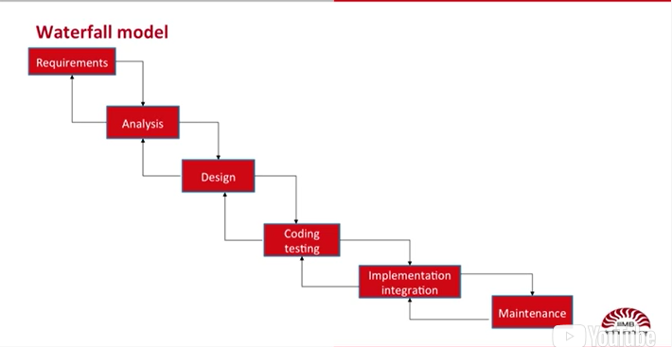

1. The need for the system is highlighted through a discussion of the problem and how a system could solve the problem.
2. This is known as a Requirement document.
3. The next step is that of Analysis.
4. Analysis is similar to Requirements in that the need of the system is specified, but with a little more detail.
5. At this step, the specifics of what the system has to do are outlined.

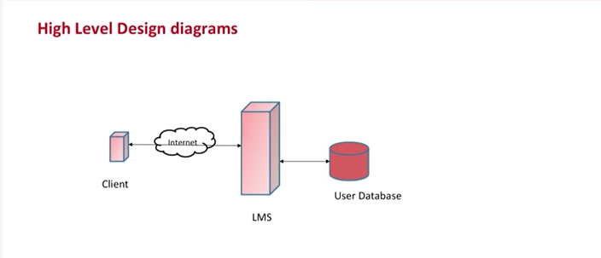

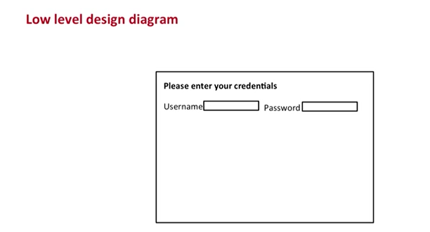

No code is written at the design step

**Prof: Coding is done in the next step. In the Coding and Testing step, code is written and the system is built.**

1. Coding involves testing, which is the practice of running the code with different types of data...
2. **...and in different situations to check if the software is working okay. If the tests fail, then the code has to be rewritten.**

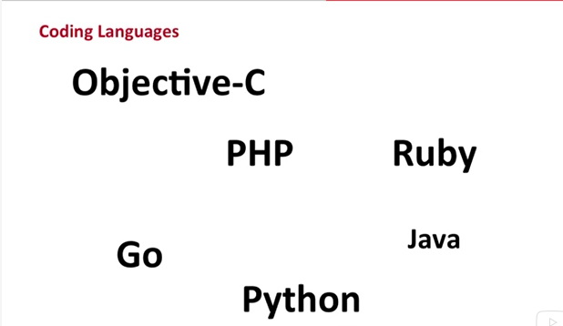

1. Prof: There are many computer languages and programmers use them depending...
2. ...on the needs of the system and also based on their own preferences.
3. Some modern languages, Java for instance, are very good for building systems that will operate online.
4. **Whereas other languages, such as Python, are good for data analysis tasks.**
5. Once the coding is done and the system is built, in the next step, the system is implemented at the site.

3 Steps

1. The Waterfall model is very widely used for software development because it has three very important management advantages.
2. **First, all the steps are formal and require that those who are involved with building the system, including those who are paying for it...**
3. ...have agreed to each step. Formal signatures are usually required.
4. Second, the model specifies clearly through all the documentation what has to be built and what will be left out.
5. Sometimes users may change their requirements.
6. Managers have to decide whether to include these ne–new requirements or not.
7. Third, note that each step has a reverse arrow going back to the previous steps.
8. This means that if changes have to be made, these can be made by going back to one prior step.
9. If changes are made in documents made in earlier stages, when the whole process is at a later stage, then the cost of changes is very high.
10. Changes, and mistakes, should be found as early as possible, otherwise the costs of fixing or changing things becomes very high.
11. The Waterfall model is widely used in the software industry to make software...
12. ...but it is also regarded as being very bureaucratic and time-consuming.
13. Other models have now come up, such as Agile, which overcome the problems of...
14. ...excessive documentation and high cost of finding errors at a later stage.
15. [End of transcript. Skip to the start.](https://courses.edx.org/courses/course-v1:IIMBx+IS110x+2T2018/courseware/63e5c43f4a43440d98ff0269ca498bb7/d00c588333ea45d59cd34de4eaed40c9/?child=first#transcript-start-188a8f8727374661802e51fbecdeffa5)

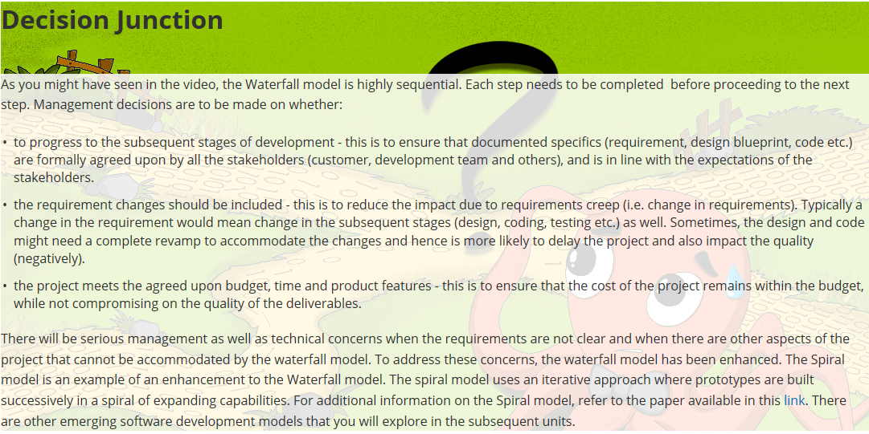

Scope creep

1. This is called scope creep or requirements creep in software project management.
2. **This changing scope never allows the project to focus or settle on one design, and leads to problems in the eventual product.**

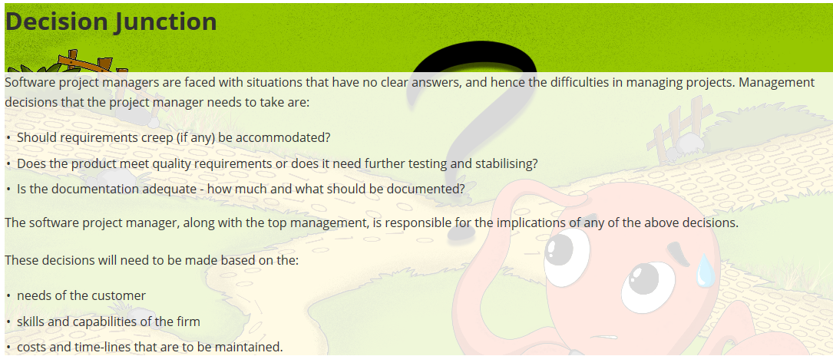

Agile method

1. A new breed of software development methods called “Agile” are now gaining ground amongst software developers.
2. The methods are adaptive in nature and are seen to be more suitable for handling changes in–and uncertainties in software development.
3. Some of the common agile methodologies include Scrum, Extreme Programming or XP, Crystal and Adaptive Software development.
4. We will use Scrum as an example to understand agile methods and how these are different from Waterfall.

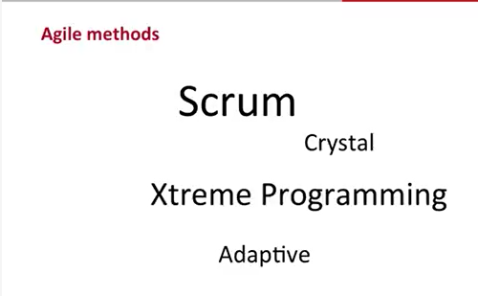

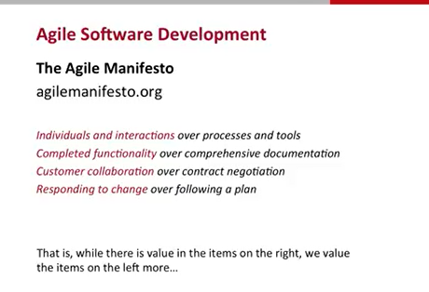

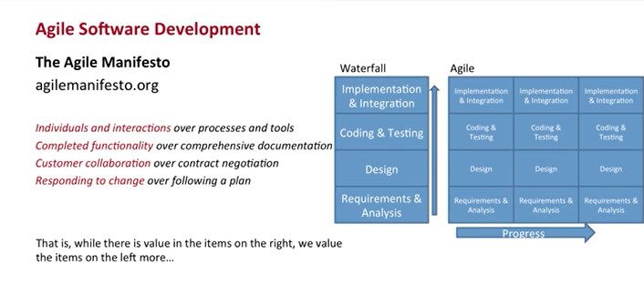

Scrum

1. **This approach of a cross-functional team going the distance as a unit, passing the ball back and forth is what agile scrum is about.**
2. Scrum can be seen as consisting of roles, events and artifacts.
3. The three core roles in Scrum are—the Product Owner, the Scrum Master and the Developers.

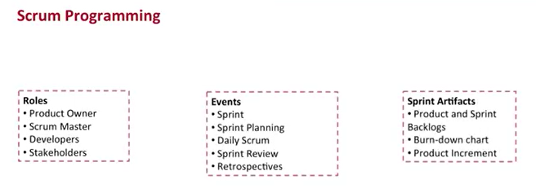

1. Apart from this, there could be different stakeholders such as clients, management and support teams who are involved.
2. The product owner owns the requirements and it is his or her job to ensure that requirements...
3. ...from business owners are communicated to the scrum team.
4. **The scrum is facilitated by the scrum master who is responsible for removing any impediments the team faces.**
5. The scrum master is not a project manager: the team is expected to self-manage and the scrum master acts as a facilitator.
6. Then there are a set of events starting with a sprint.
7. A sprint is an iteration that is time-boxed usually from two to four weeks.
8. While there could be one week sprints also, it is generally not recommended to have a sprint duration of more than a–one calendar month.
9. A sprint commences with a sprint planning meeting which is time-boxed to a few hours—usually 4 hours for a two-week sprint.
10. There is a daily scrum meeting which is used to discuss the progress and to collaborate with other team members.
11. The sprint ends with a sprint review that is usually a demo of the developed system...
12. ...to the end user and concludes with a sprint retrospective.
13. Finally, there are a set of scrum artifacts, such as the Product and the Sprint backlogs.
14. A backlog is basically a prioritized list of requirements or tasks for the scrum team to act upon.

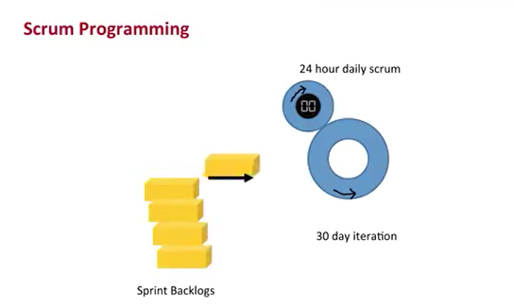

1. Another artifact is the burn-down chart which is a progress tracker of the sprint activities.
2. Finally, there is the product increment—a working software that is developed during the sprint.
3. **Note the lack of documentation in the artifact list, such as design specifications or test plans.**
4. This is consistent with the agile manifesto of “completed functionality over comprehensive documentation”.
5. The team meets during the daily scrum to review progress, plan activities and collaborate with each other.
6. The burn-down chart is used to track progress and take corrective actions.

Scrum

1. In Scrum, requirements are captured as epics and user stories that are maintained in a product backlog.
2. **A user story describes a functionality that is of value to a user and is usually described in the format: “As a user...., I wish to...., so that I can.”**
3. In other words, it captures who conducts the action, what action is performed, and the reason why the action is performed.
4. There are usually three aspects of a user story:
5. a) It should be a one-liner such that it can be captured on a post-it card.
6. **b) Details about the user story are fleshed out through conversations between the users and the developers.**
7. c) An acceptance criteria defined for the user story specifies how the functionality will be tested The start point of a user story is an epic.
8. Epics are the initial set of functionalities defined as part of the product vision.

An epic is split into multiple user stories by the product owners in discussion with the business users.

**There are three epics—one from the user perspective, and two from the librarian perspective.**

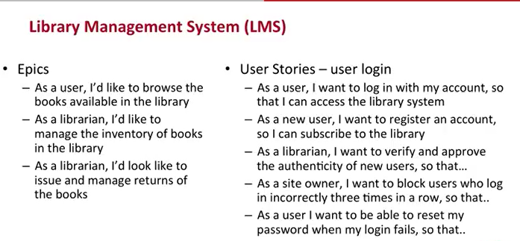

1. A Scrum project comprises of multiple sprints.
2. A sprint starts with sprint planning, during which, the product owner presents the prioritized list of the product backlog to the team.
3. Now let’s take the LMS system again.
4. Assume that the product owner suggests that the first sprint goal is to create a database of the books and the subscribers.
5. This goal consists of user stories that fall into the first two epics.
6. After the sprint planning, the scrum team participates in development of the user stories.
7. **Scrum meeting happens daily, at a fixed time, usually time-boxed to 10 or 15minutes.**
8. This meeting is a stand-up meeting that the entire scrum team attends.
9. Anybody else who are interested in the progress of the project may also attend but are not allowed to speak in the meeting.
10. Guru: Standup meetings could be painful for coders with only two legs.
11. I have heard they dislike standing up and don't want to speak anyway.
12. Prof: The sprint concludes with a sprint review which is a demo of the developed functionality to the users of the system.
13. The feedback so obtained is entered into the product backlog and shapes the direction of future sprints.
14. The basic approach here is to develop a small increment of the system, present it to the users...
15. ...take their feedback and change the requirements as needed to accommodate this feedback.
16. The last activity of a sprint is the sprint retrospective, which is again attended by the entire team.
17. The objective of this meeting is to retrospect on what worked for the team and what did not.
18. [End of transcript. Skip to the start.](https://courses.edx.org/courses/course-v1:IIMBx+IS110x+2T2018/courseware/63e5c43f4a43440d98ff0269ca498bb7/9d7add009ab548bfb470cac14a6fe475/?child=first#transcript-start-915091d3fabe4982a199ce6deea12599)

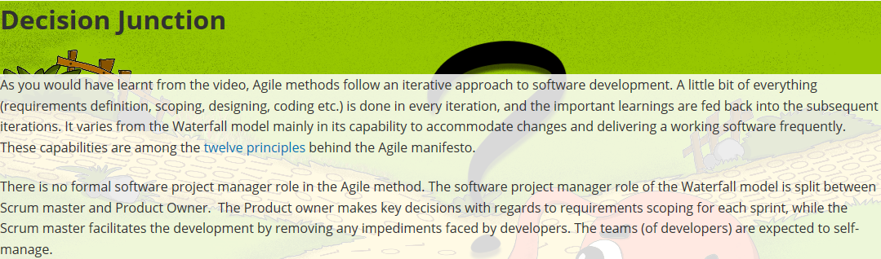

After completing this unit, you will understand the basic concept of crowdsourcing and the properties that enable crowdsourcing. You will also get to think about the challenges and management aspects related to crowdsourcing.

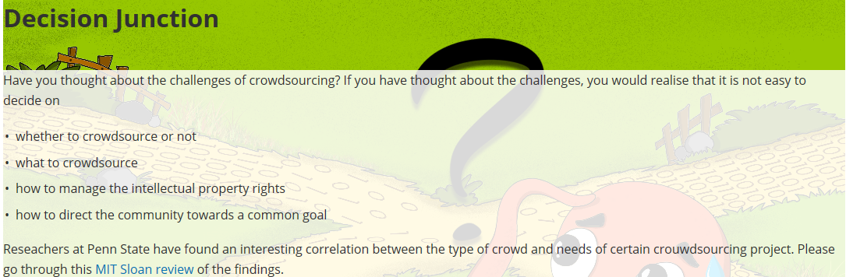

Open Source Software

1. MIT scientist Richard Stallman first came up with the idea of a software licence that allows people who write software...
2. ...to freely distribute it to others and make sure that it stays "free" in this manner.
3. Free software originated from this idea. Stallman created a licence called the Gnu Public License or GPL.
4. When software is created and released under the GPL licence...
5. ...it allows anyone to use the software, see the source code used to make the software...
6. ...make changes to the source code and also share and distribute the modified software.
7. These are known as the four freedoms of free software.

4 freedoms of free software

Anyone can use the software

Anyone can see the source code used to make the software

Anyone can make changes to the source code

Anyone can share and distribute the modified software

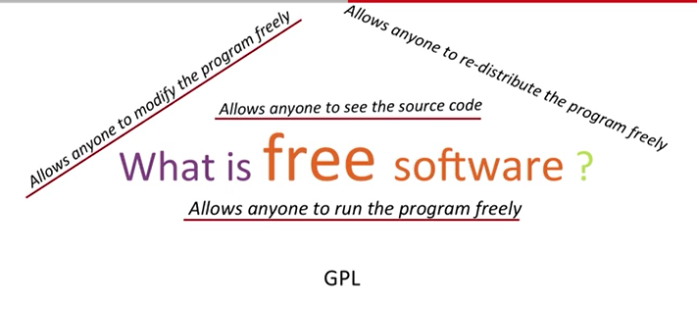

1. So the GPL licence was a radical departure. It allowed software to become a public good.
2. With the advancement of the Internet, software that is created as free software can be legally distributed openly.
3. The main difference is that where proprietary software restricts usage and distribution...
4. ...to only those who have paid for the licence, free software lets anyone use the software and distribute it also.

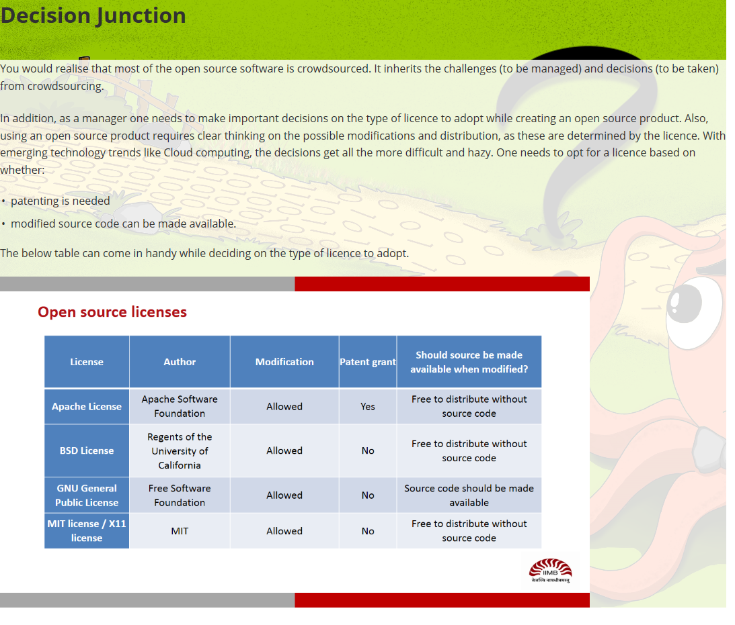

Managing Outside Innovation

In the last two units of this section, you were introduced to the nature and properties of crowdsourced and open source projects. In this unit, you will learn the guiding principles that can be used to decide:

* whether to adopt outside innovation
* how to motivate external contributors
* the platform that can be adopted for outside innovation

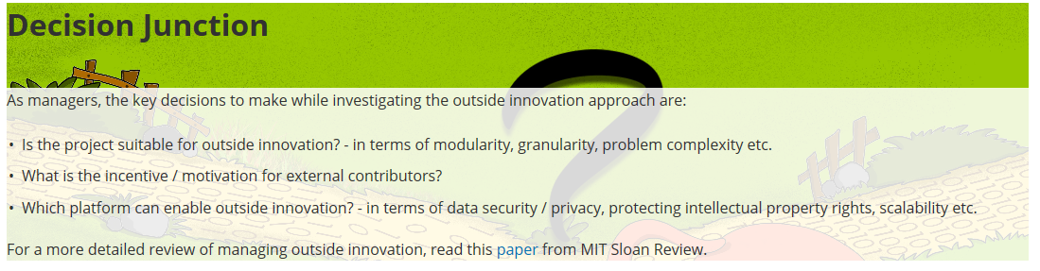

Managing ethical issues

1. Some of these issues are legal, in the sense that they invoke some applicable laws of the land.
2. **Others are ethical concerns for managers, in the sense that they are not guided by any laws...**
3. ...but pertain to the moral rules of conduct acceptable in society.
4. **Typical ethical issues include privacy, workplace monitoring and power over users.**

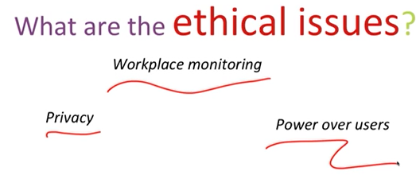

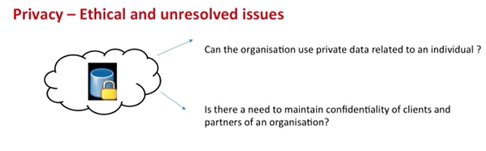

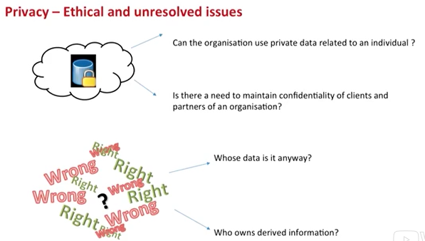

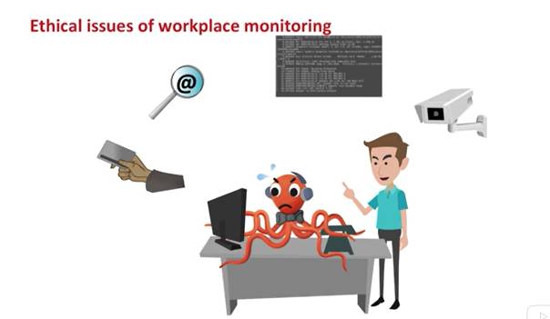

1. Employees adjust to the situation.
2. Employees may engage in "presenteeism", where they behave in one manner while being watched...
3. ...and differently while not being monitored.
4. The challenges of monitoring can be understood from the nature of the panopticon.
5. This was an eight-sided structure designed for jails by 19th century philosopher and economist Jeremy Bentham.

Exercise of Power

1. Exercise of power may happen in different situations.
2. When an IT professional simply asserts a fact, that a non-professional is not aware of...
3. ...and cannot contest, this is known as a technical exercise of power.

Governments of many countries believe that introducing information and communication technologies will improve the living conditions of people. When citizens believe this, it is a symbolic exercise of power

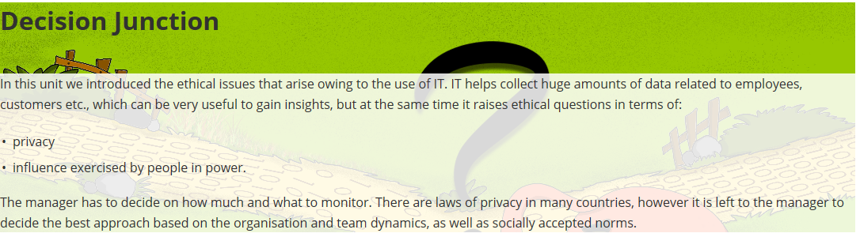

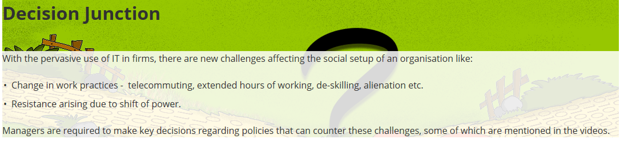

Managing Green IT

1. Burning of fossil fuels adds greenhouse gases to the atmosphere.
2. Carbon dioxide is the main greenhouse gas that is increased as energy consumption increases.
3. It is estimated that use of information technology contributes almost 2-2.5% of carbon dioxide emissions across the globe.
4. Smart systems have been designed to be used in buildings that can monitor and control the amount of electricity being used.
5. For instance, if a corridor in a building is lit with signs or lights wh–when people are present...
6. ...digital sensors detect when people have left and automatically dim or turn off the lights.
7. Entire buildings, campuses and now entire cities are being embedded with sensor devices...
8. ...that allow monitoring of temperature, water flows, electricity use, traffic flows, air particle levels, and so on.
9. These allow policies to be implemented to manage Green IT.
10. These systems are expensive to install but they pay off in terms of the long term effects of reduced consumption.
11. Managers have to decide where to implement monitoring for best results.

Manging Green IT involves managing paper consumption, energy and resource consumption, Procurement-use-disposal cycle of IT to reduce consumption of hardware

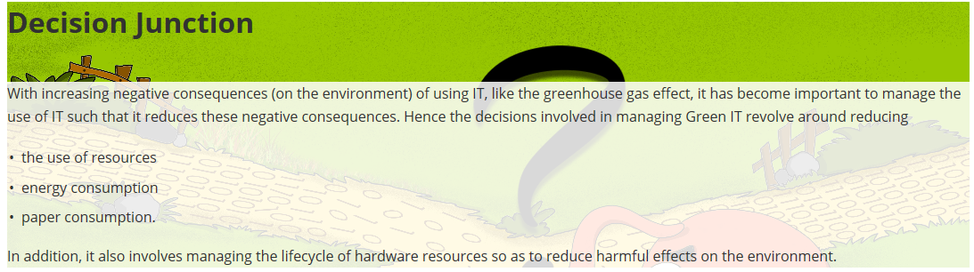

ICT information and communications technology

1. There is a belief that information and communication technologies, also called ICT, leads to development.
2. ICT collectively includes computers and networks, radio and television.
3. The belief is that when entire nations invest in ICT their economic development improves.

**Easy. Economic development is when everyone has a job, a car, some savings, and some leisure.**

